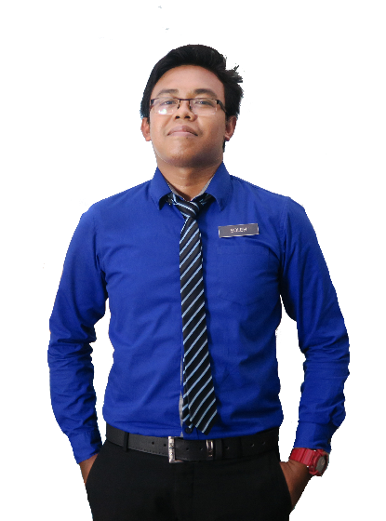

**EN. MUHAMAD SOLEH HUDIN**

Principal

SMK Bandar Baru Sungai Buloh

Phone: 06-4349162Email: smkbbsb@gmai.com

Principal

SMK Bandar Baru Sungai Buloh

Phone: 06-4349162Email: smkbbsb@gmai.com

**EN. MUHAMAD SOLEH HUDIN**

**REFERENCES**

Communication

**PER SKILLS**

Creativity

Team Work

Personality

**PRO SKILLS**

Photoshop

Illustrator

Indesign

SPSS

Master’s degree in Science with four years’ experience teaching high school Science, Chemistry, and Additional mathematic. Certification in teaching Science and also professional in graphic design and video editor.

* Graphic Design Award 2015, Kuala Lumpur
* Anugerah Guru Cemerlang SMK Bandar Baru Sungai Buloh 2016
* Larian Hari Sukan Negara 2016, UiTM Kampus Puncak Alam
* Volunteer for SUKMA 18, Pahang Darul Makmur
* Creative and Innovation Awards 2017

**ACHIEVEMENT**

Implements curriculum objectives and goals using effective teaching techniques and materials. Develops, in a cooperative manner with the principal and curriculum facilitators, a plan for the improvement and enrichment of instruction.

1995 - 2000

Teacher

**SEKOLAH MEN KEB KUALA TEKAL, PAHANG**

Implements curriculum objectives and goals using effective teaching techniques and materials. Develops, in a cooperative manner with the principal and curriculum facilitators, a plan for the improvement and enrichment of instruction.

1995 - 2000

Teacher

**SEKOLAH MEN KEB BANDAR BARU SG BULOH**

Teach at undergraduate and graduate level in areas allocated by the Head of Department and reviewed from time to time by the Head of Department. Carry out research and produce publications, or other research outputs, in line with personal objectives agreed in the Staff review process.

1995 - 2000

Lecturer

**UNIVERSITI TEKNOLOGI MARA SHAH ALAM**

**WORK EXPERIENCE**

**KOLEJ MATRIKULASI KEDAH, CHANGLUN**

Science Stream (Module II)

1995 - 2000

CGPA: 3.93

**SEKOLAH MEN KEB JELAI (F), GEMAS**

Sijil Pelajaran Malaysia

1995 - 2000

Bachelor of Education in Science (Hons) Chemistry

**UNIVERSITI TEKNOLOGI MARA PUNCAK ALAM**

1995 - 2000

CGPA: 3.93

CGPA: 3.93

Master of Education in Chemistry

**UNIVERSITI TEKNOLOGI MARA SHAH ALAM**

1995 - 2000

resumecreative@yahoo.com

GRAPHIC DESIGNER & TEACHER

**ABOUT ME**

**EDUCATION**

**ADDRESS**

**PHONE**

**EMAIL**

013-2805916

Creative Resume, 74000 Bandar Puncak Alam, Selangor

**MUHD SOLEH**